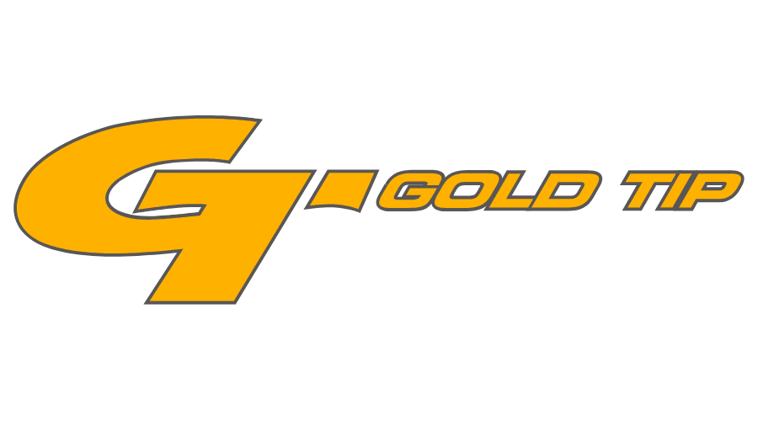

FOR IMMEDIATE RELEASE
Gold Tip Wins BowHunterPlanet’s
Golden Arrow Bronze Award for Best Arrows
FLORA, Miss. – October 26, 2021 – Gold Tip, an industry leader in carbon arrows and bolts, has won a bronze Golden Arrow award for best hunting arrows from BowHunterPlanet. The inaugural awards aim to recognize the BowHunterPlanet audience’s favorite brands across various categories and is decided by popular online voting.
Gold Tip offers a variety of high-performance arrows. The Gold Tip Airstrike features an ultra-light .204 inside diameter profile with an extreme front of center design, high modulus carbon construction and exclusive Dyna-Tek Slick Shield® coating. Built for speed and long-range accuracy, the Airstrike closes long distances faster and penetrates deeper with pinpoint accuracy. It’s one of the fastest, most versatile long-range hunting arrows around.
Other popular arrows for hunting include the Gold Tip Hunter Series and Velocity Series. To learn more about Gold Tip and to see their full lineup of arrows, visit goldtip.com.
About Gold Tip
Gold Tip, a Vista Outdoor brand, is an archery manufacturer of the most innovative, durable and precise carbon arrows in the world. Every Gold Tip arrow is manufactured from the finest aerospace-grade materials, and built to meet the industry’s weight and straightness specifications. Gold Tip’s products are supported by a network of knowledgeable and friendly employees, dealers, and distributors. That’s why many of the world’s top professional archers depend on Gold Tip, and why bow hunters and archers claim that Gold Tip makes the toughest arrows they’ve ever shot. For news and product information, go to www.goldtip.com or follow us on Facebook at https://www.facebook.com/goldtiparrows/ and Instagram https://www.instagram.com/goldtiparrows/.
Contact: Matt Rice
Sr. Manager Media Relations
Outdoor Products
(913) 689-3713
Matt.rice@VistaOutdoor.com

Product Requests: Will Folsom
Public Relations Associate
Swanson Russell
(402) 437-6404
willf@swansonrussell.com

###

